*A project report on*

# FOOD ORDERING CHATBOT USING FASTAPI

*Submitted in partial fulfillment for the award of the degree of*

## BACHELOR OF TECHNOLOGY

## IN

## COMPUTER SCIENCE AND ENGINEERING

*by*

**B. SASI PREETHAM(20BCE7362)**

**G. TEJA NAGA SAI(20BCE7361)**

*Under the Guidance of*

**Dr. Ganesh Reddy Karri**

**SCHOOL OF COMPUTER SCIENCE AND ENGINEERING**

**VIT-AP UNIVERSITY**

**AMARAVATI-522237**

May,2024

**DECLARATION**

I here by declare that the thesis entitled “FOOD ORDERING CHATBOT USING FASTAPI” submitted by me, for the award of the degree of Specify the name of the degree VIT is a record of bonafide work carried out by me under the supervision of Guide Name.

I further declare that the work reported in this thesis has not been submitted and will not be submitted, either in part or in full, for the award of any other degree or diploma in this institute or any other institute or university.

Place: Amaravati

Date: Signature of the Candidate

**CERTIFICATE**

This is to certify that the Senior Design Project titled “**FOOD ORDERING CHATBOT USING FASTAPI**” that is being submitted by **B.SASI PREETHAM(20BCE7362),** is in partial fulfillment of the requirements for the award of Bachelor of Technology, is a record of bonafide work done under my guidance. The contents of this Project work, in full or in parts, have neither been taken from any other source nor have been submitted to any other Institute or University for award of any degree or diploma and the same is certified.

**Guide**

**The thesis is satisfactory / unsatisfactory**

**Internal Examiner External Examiner**

**Approved by**

**PROGRAM CHAIR DEAN**

B. Tech. CSE School Of Computer Science and Engineering

**ACKNOWLEDGEMENT**

It is my pleasure to express with deep sense of gratitude to Dr.Ganesh Reddy Karri,

Associate Professor, School of Computer Science and Engineering, VIT-AP, for his/her constant guidance, continual encouragement, understanding; more than all, he taught me patience in my endeavor. My association with him / her is not confined to academics only, but it is a great opportunity on my part of work with an intellectual and expert in the field of Computer and Network Security, Cloud computing, Wireless networks, Data structures and Algorithms.

I would like to express my gratitude to Dr. G. Viswanathan, Dr. S.V. Kota Reddy, and Dr. Pradeep Reddy CH, School of Computer Science and Engineering for providing with an environment to work in and for his inspiration during the tenure of the course.

In jubilant mood I express ingeniously my whole-hearted thanks to Dr. Saroj Kumar Panigrahy, Programme Chair, BTech(CSE) all teaching staff and members working as limbs of our university for their not-self-centered enthusiasm coupled with timely encouragements showered on me with zeal, which prompted the acquirement of the requisite knowledge to finalize my course study successfully. I would like to thank my parents for their support.

It is indeed a pleasure to thank my friends who persuaded and encouraged me to take up and complete this task. At last but not least, I express my gratitude and appreciation to all those who have helped me directly or indirectly toward the successful completion of this project.

Place: Amaravati Name of the student

Date: B.Sasi Preetham

**ABSTRACT**

In the food industry, integrating chatbot technology into business operations has become increasingly prevalent for enhancing customer engagement and streamlining the ordering process. This study explores the implementation of a chatbot for a food business’s website, focusing on two main features: new order placement and order tracking. The research identifies cost-effective solutions with minimal learning curves to facilitate the development of the chatbot. The study begins by selecting a suitable chatbot platform, considering factors such as ease of use, integration capabilities, and cost-effectiveness. Options such as Dialogflow are evaluated for their ability to facilitate conversational design and integration with external databases. Next, the integration of the chatbot with a MySQL database for order management is discussed. Leveraging the existing database infrastructure of the food business, the chatbot is programmed to store new orders and retrieve order details for tracking purposes. Integration methods and data handling practices are outlined to ensure seamless communication between the chatbot and the database. The implementation of the new order feature involves designing a conversational flow that guides users through the food selection process, collects relevant order information, and confirms the order placement. User interactions are simulated through intuitive prompts and responses, allowing for a user-friendly ordering experience. Similarly, the order tracking feature is developed to enable users to inquire about the status of their orders.

## TABLE OF CONTENTS

|  |  |  |  |
| --- | --- | --- | --- |
| **S.NO** | **CHAPTER** | **TITLE** | **PAGE NO** |
| **1** |  | **ACKNOWLEDGEMENT** | 4 |
| **2** |  | **ABSTRACT** | 5 |
| **3** |  | **LIST OF FIGURES** | 7 |
| **4** | **1**  **1.1**  **1.2**  **1.3**  **1.4** | **INTRODUCTION**  **OBJECTIVES**  **BACKGROUND**  **LITERATURE SURVEY**  **ORGANIZATION OF REPORT** |  |
| **5** | **2**  **2.1**  **2.2**  **2.3**  **2.4** | **IMPLEMENTATION OVERVIEW**  **PROPOSED SYSTEM**  **WORKING METHODOLOGY**  **TOOLS AND TECHNOLOGIES**  **IMPLEMENTATION** |  |
| **6** | **3** | **RESULTS AND DISCUSSIONS** |  |
| **7** | **4** | **CONCLUSION AND FUTURE SCOPE** |  |
| **8** | **5** | **APPENDIX** |  |
| **9** | **6** | **REFERENCES** |  |

**LIST OF FIGURES**

**CHAPTER-1**

**INTRODUCTION**

In today's competitive food industry, businesses are always on the lookout for innovative ways to enhance customer satisfaction and streamline operations. Chatbots have emerged as a promising solution, offering a convenient means of communication between businesses and their customers. By integrating chatbot technology into their websites, food businesses can provide customers with a seamless ordering experience while also improving efficiency behind the scenes. Whether it's a small local eatery or a larger restaurant chain, the adoption of chatbots enables businesses to stay connected with their customers 24/7, catering to their needs in real-time.

This project report focuses on the development and implementation of a chatbot tailored specifically for food businesses. With a primary emphasis on two key functionalities – facilitating new orders and enabling order tracking – the aim is to provide businesses with a practical and accessible guide to harnessing the power of chatbots. By leveraging cost-effective solutions and minimizing the learning curve, businesses can effectively integrate chatbots into their existing operations without significant investment or technical expertise. Through the implementation of these features, food businesses can not only enhance the customer experience but also optimize internal processes, leading to improved productivity and profitability.

Throughout this report, we will delve into the various aspects of building and deploying a chatbot for a food business's website. From selecting the right chatbot platform to integrating it with existing databases, and from designing conversational flows to conducting thorough testing, each step is carefully outlined to ensure a smooth and successful implementation. By following the recommendations and best practices outlined in this report, food businesses can capitalize on the benefits of chatbot technology to better serve their customers, drive sales, and stay ahead of the competition in an increasingly digital landscape.

* 1. **OBJECTIVES**
* **Enhancing Chatbot Responsiveness with FastAPI Integration:** Implement FastAPI, a high-performance Python web framework, to optimize the responsiveness and speed of the chatbot, ensuring swift interactions and seamless user experiences.
* **Minimizing Misclassification Errors:** Integrate Dialogflow, a natural language understanding platform, to effectively handle user queries and minimize misclassification errors, thereby enhancing the accuracy and reliability of the chatbot's responses.
* **Simplifying User Experience with Reduced Learning Curve:** Design an intuitive user interface and implement user-friendly features to minimize the learning curve for interacting with the chatbot, ensuring that users can easily navigate and utilize its capabilities without extensive training or technical knowledge.
  1. **BACKGROUND**

In recent years, chatbots have emerged as valuable tools for businesses across various industries, including the food sector. These conversational agents utilize natural language processing (NLP) and machine learning algorithms to interact with users in a human-like manner, providing assistance, answering queries, and facilitating transactions. In the food industry, where convenience and efficiency are paramount, chatbots offer significant potential for enhancing customer service and streamlining operations.

The implementation of chatbots in the food industry is particularly relevant in the context of online ordering and delivery services. With the growing popularity of food delivery apps and websites, businesses are increasingly looking for ways to improve the user experience and differentiate themselves from competitors. Chatbots provide an opportunity to engage with customers directly on these platforms, guiding them through the ordering process, providing personalized recommendations, and addressing any issues or inquiries in real-time.

Furthermore, advancements in chatbot development frameworks and technologies have made it easier for businesses to create and deploy their own chatbots. Tools such as Dialogflow offer intuitive interfaces and robust functionalities, allowing businesses to build sophisticated chatbot solutions without extensive technical expertise. Additionally, integration with backend systems, such as order management databases, enables chatbots to seamlessly handle transactions and provide users with accurate information regarding their orders.

* 1. **LITERATURE SURVEY**

Numerous studies have explored the application of chatbots in the food industry, highlighting their potential to improve customer engagement and operational efficiency. Research by Katharina Klein & Luis F. Martinez demonstrated that chatbots can significantly enhance the ordering experience for customers, leading to increased satisfaction and repeat business. Similarly Pathan Mohd Shafi, Gauri S. Jawalkar, Manasi A. Kadam, Rachana R. Ambawale & Supriya V. Bankar found that implemention of chatbots increase sales providing great customer satisfaction.

In terms of technology, studies have focused on optimizing chatbot performance through various means, including the use of advanced NLP techniques, machine learning algorithms, and integration with third-party platforms. For instance, Ahmad Abdellatif; Khaled Badran; Diego Elias Costa; Emad Shihab proposed a comparative approach that reduce misclassification errors in chatbot interactions by Natural language platforms.

Overall, the literature suggests that chatbots hold tremendous potential for transforming the food industry by providing customers with seamless ordering experiences, improving operational efficiency, and driving business growth. However, further research is needed to explore specific challenges and opportunities associated with chatbot implementation in different food business contexts, as well as to identify best practices for maximizing the benefits of this technology.

* 1. **ORGANISATION OF REPORT**

The remaining chapters of the project report are described as follows:

* Chapter 2 contains the detailed implementation for the project
* Chapter 3 discusses the results obtained after the project was implemented.
* Chapter 4 concludes the report.
* Chapter 5 consists of codes.
* Chapter 6 gives references.

**CHAPTER-2**

**IMPLEMENTATION OVERVIEW**

The implementation overview of the food ordering chatbot encompasses the integration of multiple technologies and components to create a seamless user experience. At its core, the system leverages FastAPI, a modern web framework for building APIs with Python, to develop the backend infrastructure. FastAPI facilitates the creation of endpoints to handle HTTP requests from the chatbot frontend, enabling functionalities such as retrieving menu items, processing orders, and managing user interactions.

In conjunction with FastAPI, the chatbot utilizes Google Dialogflow, a natural language understanding platform, to process user queries and intents. Dialogflow employs advanced natural language processing (NLP) techniques to analyze user messages, identify their intent (e.g., placing an order), and extract relevant entities (e.g., food items, quantities). This integration enables the chatbot to understand and respond to user requests in a conversational manner, enhancing the overall user experience.

Complementing the backend infrastructure, the food ordering chatbot incorporates a dedicated food website to provide users with a visually appealing and intuitive interface for browsing menus, customizing orders, and completing transactions. The website interacts with the FastAPI backend to fetch dynamic data such as menu items and process orders in real-time. Additionally, the website integrates secure payment processing mechanisms to facilitate seamless transactions and ensure user satisfaction.

Overall, the implementation of the food ordering chatbot involves the seamless integration of FastAPI, Google Dialogflow, and a user-friendly food website. This comprehensive approach enables the chatbot to understand user requests, process orders efficiently, and provide a seamless ordering experience for customers. By leveraging cutting-edge technologies and robust backend infrastructure, the chatbot enhances customer engagement and streamlines the food ordering process, ultimately driving business growth and customer satisfaction.

**2.1 PROPOSED SYSTEM**

The proposed system aims to develop an intuitive and efficient food ordering chatbot, enhancing the convenience of ordering food from a restaurant or food establishment. By integrating cutting-edge technologies and a user-friendly interface, the chatbot will streamline the ordering process from menu exploration to order placement.

**Key Components:**

**Natural Language Understanding:** The natural language understanding component of the proposed system is facilitated by Google Dialogflow, which enables the chatbot to process user messages and accurately interpret their intents and preferences. Through Dialogflow, predefined intents and entities are defined to capture user requests related to food ordering, menu exploration, and customization options. This component plays a crucial role in enabling seamless communication between users and the chatbot, ensuring that user queries are understood and responded to appropriately.

**Backend Infrastructure:** Backing the natural language understanding component is a robust backend infrastructure developed using FastAPI. FastAPI serves as the backbone of the system, handling communication between the chatbot frontend and backend services. It provides endpoints for various functionalities such as retrieving menu items, processing orders, managing user sessions, and updating the database with order details. This backend infrastructure ensures efficient handling of user requests, seamless order processing, and accurate management of order data, contributing to a smooth and hassle-free user experience.

**User Interface:**

Complementing the natural language understanding and backend infrastructure is a user-friendly interface designed to facilitate user interaction and streamline the ordering process. The user interface, accessible through messaging platforms or a dedicated website, allows users to engage with the chatbot intuitively, browse menus, select items, and customize orders with ease. Responsive design principles are employed to ensure compatibility across different devices and screen sizes, enhancing accessibility and usability for a diverse user base. Together, these key components form the foundation of the proposed system, enabling the food ordering chatbot to deliver a seamless and efficient ordering experience for users, from menu exploration to order placement and confirmation.

**2.2 WORKING METHODOLOGY**

* **Designing Conversation Flow in Dialogflow:** This step involves creating the conversational structure within Dialogflow. It includes defining intents to capture user requests and specifying the corresponding responses or actions. Intents represent the different actions or topics the chatbot can handle, such as placing an order, checking the menu, or providing assistance. Dialogflow's graphical interface allows for the intuitive creation and visualization of conversation flows, enabling developers to design a user-friendly and coherent chatbot experience.

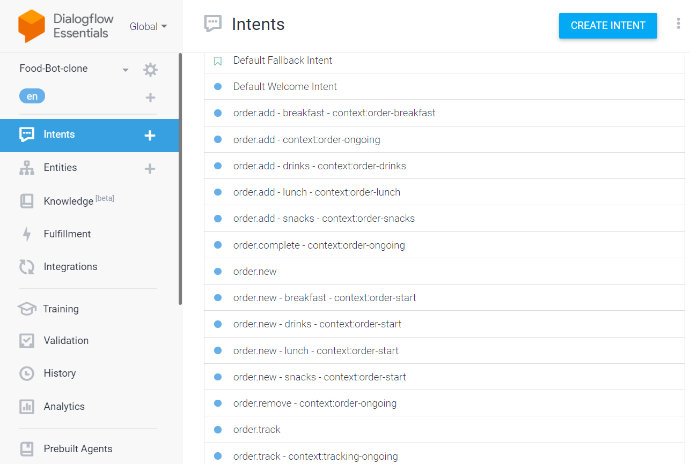

Figure 1- Intents in chatbot

* **Developing FastAPI Backend for Handling Requests:** In this phase, developers create a robust backend infrastructure using FastAPI. FastAPI is utilized to build endpoints that handle HTTP requests from the chatbot frontend. These endpoints are responsible for processing user requests, interacting with the database, and executing business logic. FastAPI's asynchronous capabilities and automatic documentation generation streamline the development process, facilitating the creation of efficient and maintainable backend services.
* **Integrating Dialogflow with FastAPI:** Integration between Dialogflow and FastAPI is essential for enabling seamless communication between the chatbot frontend and backend services. Developers establish a connection between Dialogflow and FastAPI, allowing user messages received by Dialogflow to be forwarded to the FastAPI backend for processing. This integration ensures that user requests are handled appropriately and responses are generated based on the backend's logic and data.
* **Setting Up and Managing MySQL:** The setup and management of MySQL involve creating and configuring the database to store relevant data such as menu items, user profiles, and order information. Developers define database schemas, tables, and relationships to organize and manage data effectively. Additionally, they implement database access methods within the FastAPI backend to interact with MySQL, allowing for seamless data retrieval, insertion, and modification operations.

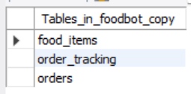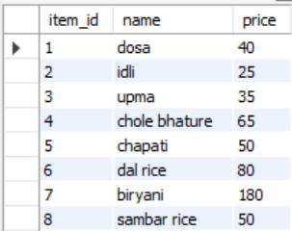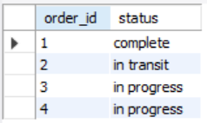

Figure 2- Tables in SQL Figure 3- Food Items Figure 4- Order progress

* **Developing User-Friendly Website:** This step focuses on designing and developing a user-friendly website interface for the chatbot. The website serves as an additional access point for users to interact with the chatbot and place orders. Developers leverage frontend technologies such as HTML, CSS, and JavaScript to create an intuitive and visually appealing interface. Responsive design principles ensure that the website is accessible across various devices and screen sizes, enhancing user experience and accessibility.

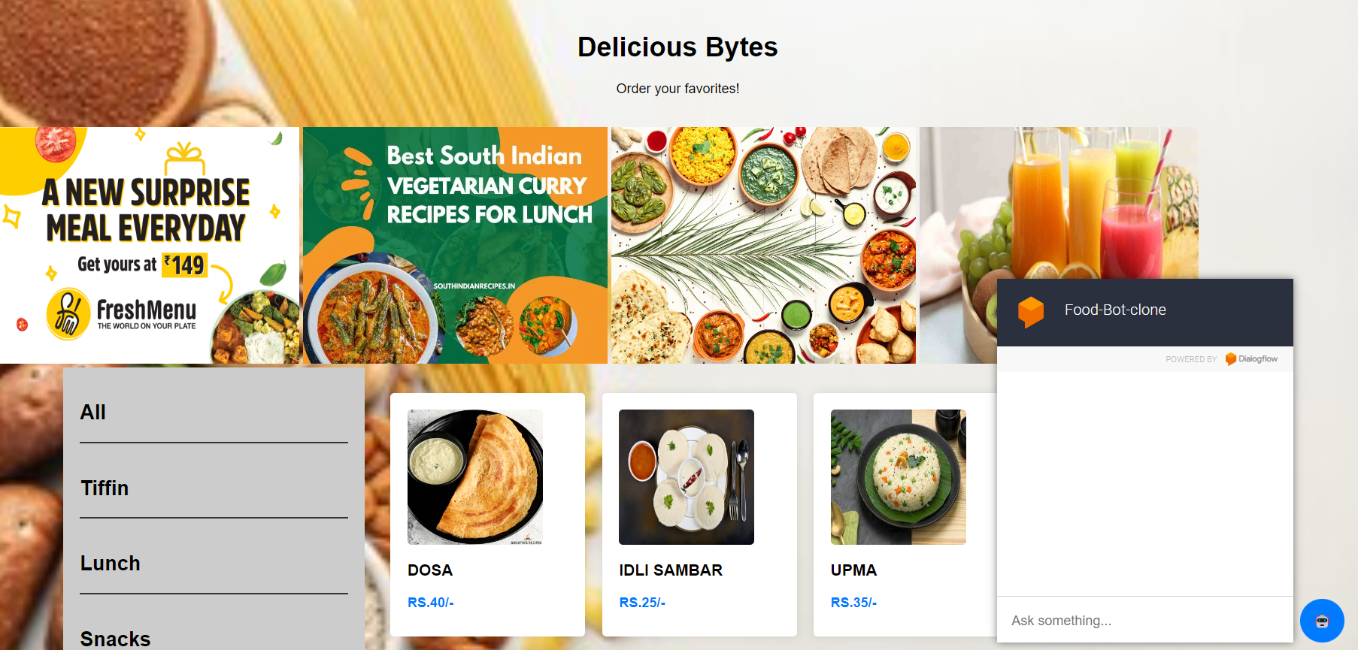

Figure 5- User Interface

* **Testing the Chatbot Functionality:** Testing is a crucial phase to ensure the reliability, performance, and accuracy of the chatbot's functionality. Developers conduct various types of testing, including unit testing, integration testing, and end-to-end testing, to validate the behavior of the chatbot under different scenarios. This involves testing the conversation flow, backend logic, database interactions, and website functionality to identify and address any bugs, errors, or inconsistencies. Testing ensures that the chatbot meets quality standards and provides users with a seamless and satisfying experience.

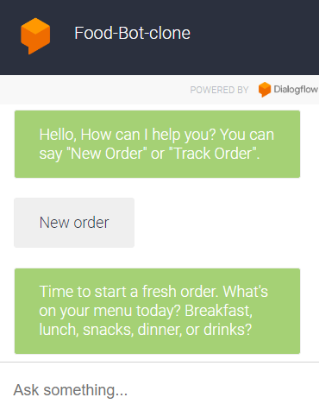

Figure 6- Chat interface

**2.3 TOOLS AND TECHNOLOGIES**

**Visual Studio Code:**

Visual Studio Code (VS Code) is a popular and versatile source code editor developed by Microsoft. It offers a wide range of features and extensions that enhance productivity and streamline the development process for various programming languages and frameworks.



VS Code is known for its lightweight and fast performance, making it a preferred choice among developers. It provides built-in support for syntax highlighting, code completion, and code navigation, enabling developers to write and edit code with ease. Additionally, VS Code offers integrated debugging tools that allow developers to debug their code directly within the editor, making it easier to identify and fix issues.

**Dialogflow:**

Dialogflow is a powerful natural language understanding platform developed by Google that enables developers to build conversational interfaces, including chatbots, virtual agents, and voice-activated applications. One of Dialogflow's key features is its robust NLP capabilities, which allow chatbots to understand and interpret natural language input from users accurately.

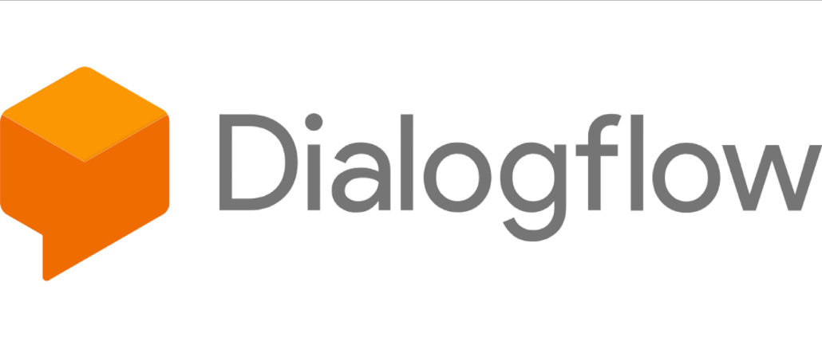

Dialogflow supports integration with multiple messaging platforms, including Google Assistant, Facebook Messenger, Slack, and more, making it versatile and widely applicable. This multi-channel support enables developers to deploy chatbots across various platforms, reaching a broader audience and providing consistent user experiences across different channels.

Moreover, Dialogflow maintains context across conversational turns, allowing chatbots to remember previous interactions and provide more contextually relevant responses. This context management feature enhances the conversational flow and enables chatbots to engage users in more meaningful and personalized interactions, ultimately improving user satisfaction and overall user experience.

**FastAPI:**

FastAPI is a modern web framework for building APIs with Python that is renowned for its high performance. It leverages asynchronous request handling, making it capable of handling a large number of concurrent requests efficiently. This asynchronous approach allows for non-blocking I/O operations, ensuring optimal utilization of system resources and enhancing scalability.



In addition to its performance benefits, FastAPI is designed to be easy to use and intuitive. It offers automatic API documentation generation based on Python type hints, enabling developers to document their APIs effortlessly. FastAPI also provides built-in support for data validation, serialization, and dependency injection, simplifying the development process and reducing boilerplate code.

**MySQL:**

MySQL are widely used relational database management systems (RDBMS) that can be used to store and manage data related to menu items, user profiles, orders, and transactions. These databases offer features such as data integrity, scalability, and ACID compliance, making them suitable for building robust and scalable applications.



**HTML/CSS:** Frontend technologies such as HTML, CSS are essential for developing the user interface of the food ordering chatbot. These technologies are used to create interactive and visually appealing web interfaces that allow users to browse menus, select items, customize orders, and complete transactions seamlessly.

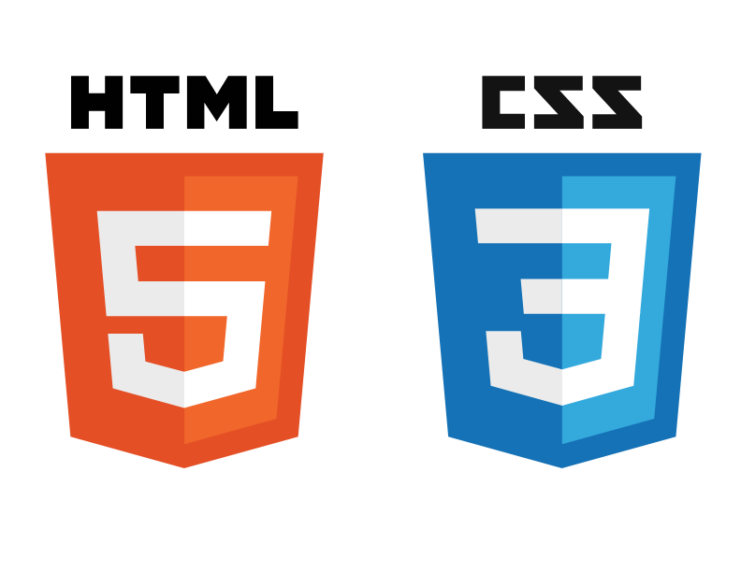

**2.4 IMPLEMENTATION**